CROATIAN LANGUAGE COURSE IN DUBROVNIK  July 11 – August 05, 2022  Centre for Advanced Academic Studies in Dubrovnik  Don Frana Bulica 4, 20000 Dubrovnik, Croatia  Our courses are following the guidelines of the Common European Framework of Reference for Languages and are structured in 6 levels. The lessons offer a variety of conversation practices, discussions, listening and reading texts as well as grammar exercises under the guidance of our highly qualified and experienced teachers. | 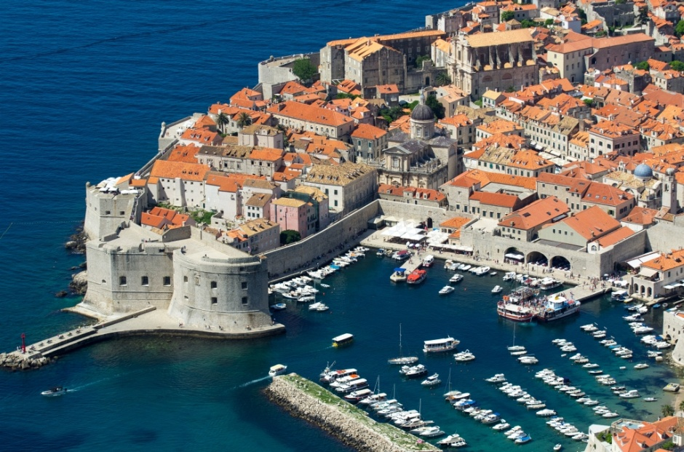
TYPE OF COURSE TERMS COURSE FEE  Regular course 20 teaching hours per week (900min) (4 teaching hours per day, Monday to Friday) ONE-WEEK 300,00 Euro  TWO-WEEK COURSE 600,00 Euro  THREE-WEEK COURSE 850,00 Euro  FOUR-WEEK COURSE 1.100,00 Euro  Teaching hour = 45 minutes  Every individual tutorial (extra teaching hour) costs 55,00 Euro  Except regular courses there is a possibility to take one-week course.  COURSE FEE INCLUDES:  - Teaching materials (student’s book, workbook, CD)  - Guided city tour  - Excursion to Dubrovnik surrounding | 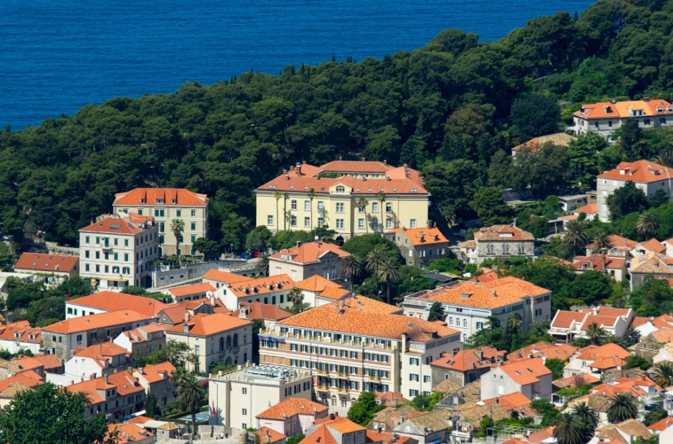
OPTIONAL (not included in the course fee):  - Optional trips or second excursion to Dubrovnik surroundings  - Tickets to museums and Dubrovnik summer festival performances/concerts  - Costs of accommodation  Accommodation in the same building where the lectures will take place  CAAS Apartments – 2nd floor Please contact: Ms. Ana Tokic Phone: 00385 (0)20 326 397 Fax: 00385 (0)20 326 390 E-mail: ana.tokic@caas.unizg.hr caas.dubrovnik@gmail.com 7 Double-bed apartments with kitchenette and bathroom a) single use price per day (Overnight stay including breakfast) b) double use price per person per day (only if there will be another participant willing to share the apartment with you) (Overnight stay including breakfast) * 01.04. -30.09. city tax is extra charge 20 kn(2.7€) pp night. 54,00 € + City Tax 22,00 € + City Tax  CAAS Residence – 3rd floor Please contact: Ms. Ana Tokic Single rooms with bathroom (Overnight stay including breakfast) 47 € +City tax  Lunch or dinner supplement 16 €  LOUNDRY per laundry machine or person 9.5 € |  | 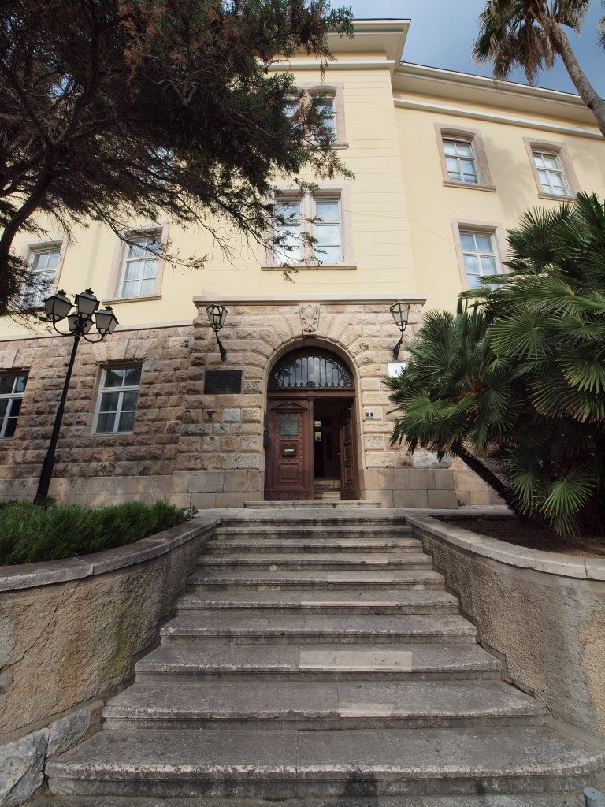  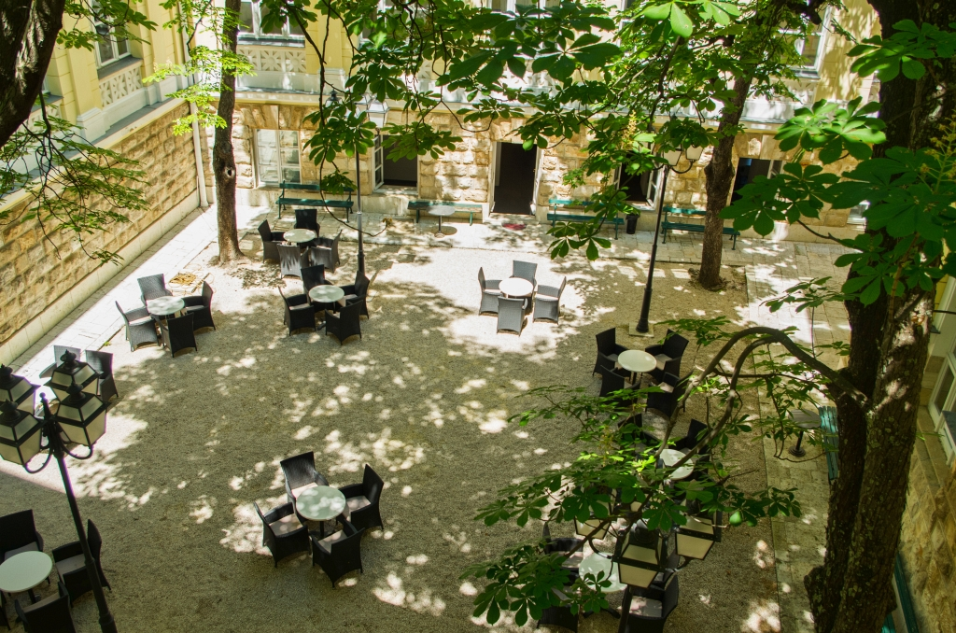
IMPORTANT INFORMATION

1. You may apply for one of the courses if you are 16 and over
2. Please send your application to the following E-mail address: ana.tokic@caas.unizg.hr ; caas.dubrovnik@gmail.com
3. For any further information you may need, please contact us:
Phone: 00385 (0)20 326 397
Contact: Ms. Ana Tokic
E-mail: ana.tokic@caas.unizg.hr caas.dubrovnik@gmail.com
4. Upon receipt of your application we will send you:
- Confirmation of your enrolment
- Payment info

5. Each course participant will get a CERTIFICATE of course attendance
6. Accommodation in the city - Boarding School /Contact: samostan.dubrovnik@gmail.com
7. Private accommodation: Our Centre is situated on Pile. When looking for a private accommodation we suggest you indicate the
location and ask for the place somewhere in the neighbourhood (Pile, Old City, Ploce or Ilijina glavica).

AGENDA 2022
1ST WEEK

Monday 11/7 | Tuesday 12/7 | Wednesday 13/7 | Thursday 14/7 | Friday 15/7 | Saturday 16/7 | Sunday 17/7
Morning or Afternoon Classes | Morning or Afternoon Classes | Morning or Afternoon Classes | Morning or Afternoon Classes | Morning or Afternoon Classes | 1st Excursion to Dubrovnik surrounding *
 | 17.00 – 19.00 Guided city tour*
2ND WEEK

Monday 18/7 | Tuesday 19/7 | Wednesday 20/7 | Thursday 21/7 | Friday 22/7 | Saturday 23/7 | Sunday 24/7
Morning or Afternoon Classes | Morning or Afternoon Classes | Morning or Afternoon Classes | Morning or Afternoon Classes | Morning or Afternoon Classes
10:00 Museum |  |  | 17.00 – 18.30 Croatian Movie *
3RD WEEK

Monday 25/7 | Tuesday 26/7 | Wednesday 27/7 | Thursday 28/7 | Friday 29/7 | Saturday 30/7 | Sunday 31/7
Morning or Afternoon Classes | Morning or Afternoon Classes | Morning or Afternoon Classes | Morning or Afternoon Classes | Morning or Afternoon Classes | 2nd Excursion to Dubrovnik surrounding*
 | 17.00 – 19.00 Guided city tour* |  |  | 17.00 – 18.30 Croatian Movie*
4TH WEEK

Monday 1/8 | Tuesday 2/8 | Wednesday 3/8 | Thursday 4/8 | Friday 5/8
Morning or Afternoon Classes | Morning or Afternoon Classes | Morning or Afternoon Classes | Morning or Afternoon Classes | Morning or Afternoon Classes
 |  |  |  | END of the course
* The exact day and the time & place will be agreed with the teachers during the course; this is proposed term.
Those who would like to have individual tutorials (extra teaching hours) will arrange the schedule and contents with teachers upon arrival.

WEEKLY TIMETABLE

Morning Classes | Monday | Tuesday | Wednesday | Thursday | Friday
Lesson 1 | 09.00 - 09.45 | 09.00 - 09.45 | 09.00 - 09.45 | 09.00 - 09.45 | 09.00 - 09.45
Lesson 2 | 09.45 - 10.30 | 09.45 - 10.30 | 09.45 - 10.30 | 09.45 - 10.30 | 09.45 - 10.30
Morning Break | 10.30 - 11.00 | 10.30 - 11.00 | 10.30 - 11.00 | 10.30 - 11.00 | 10.30 - 11.00
Lesson 3 | 11.00 - 11.45 | 11.00 - 11.45 | 11.00 - 11.45 | 11.00 - 11.45 | 11.00 - 11.45
Lesson 4 | 11.45 - 12.30 | 11.45 - 12.30 | 11.45 - 12.30 | 11.45 - 12.30 | 11.45 - 12.30
Afternoon Classes | Monday | Tuesday | Wednesday | Thursday | Friday
Lesson 1 | 13.00 – 13.45 | 13.00 – 13.45 | 13.00 – 13.45 | 13.00 – 13.45 | 13.00 – 13.45
Lesson 2 | 13.45 – 14.30 | 13.45 – 14.30 | 13.45 – 14.30 | 13.45 – 14.30 | 13.45 – 14.30
Afternoon Break | 14.30 – 15.00 | 14.30 – 15.00 | 14.30 – 15.00 | 14.30 – 15.00 | 14.30 – 15.00
Lesson 3 | 15.00 – 15.45 | 15.00 – 15.45 | 15.00 – 15.45 | 15.00 – 15.45 | 15.00 – 15.45
Lesson 4 | 15.45 – 16.30 | 15.45 – 16.30 | 15.45 – 16.30 | 15.45 – 16.30 | 15.45 – 16.30
Usually the beginner group starts with morning classes while the advance group starts with afternoon classes first week.

Those who would like to have individual tutorials (extra teaching hours) will arrange the schedule and contents with teachers upon arrival.

LITERATURE:  Marica Čilaš-Mikulić, Milvia Gulešić Machata, Dinka Pasini, Sanda Lucija Udier  HRVATSKI ZA POČETNIKE 1 – Student book and dictionary  HRVATSKI ZA POČETNIKE 1 – Student Workbook  HRVATSKI ZA POČETNIKE 1 – CD  Marica Čilaš-Mikulić, Milvia Gulešić Machata, Sanda Lucija Udier  RAZGOVARAJTE S NAMA A2B1 – Student book and dictionary  RAZGOVARAJTE S NAMA – Student Workbook  RAZGOVARAJTE S NAMA - CD  Marica Čilaš-Mikulić, Milvia Gulešić Machata, Sanda Lucija Udier  RAZGOVARAJTE S NAMA B1B2 – Student book and dictionary  RAZGOVARAJTE S NAMA – Student Workbook  RAZGOVARAJTE S NAMA - CD | Vesna Kosovac, Vida Lukić  UČIMO HRVATSKI 1 – Student book and workbook  UČIMO HRVATSKI 1 - CD  UČIMO HRVATSKI 2 – Student book and workbook  UČIMO HRVATSKI 2 - CD  (Centar za strane jezike Vodnikova i Školska knjiga)  Višnja Kostrenčić, Miljenko Kovačićek, Vida Lukić  UČIMO HRVATSKI 3 – Student book and workbook  UČIMO HRVATSKI 3 - CD  UČIMO HRVATSKI 4 – Student book and workbook  UČIMO HRVATSKI 4 - CD  (Centar za strane jezike Vodnikova)  Materials adapted to the needs of participants (individual lessons, exercises for translators)

Beside the schoolbook, teachers bring in and use extra, up-to-date materials such as excerpts from various texts, newspaper or magazine clippings or TV daily news.
In order to immerse our students in our culture, increase their educational experience and make their staying more pleasant, every year we offer some extracurricular activities such as Croatian movies showing, guided city tour and excursion to Dubrovnik surrounding.

